ASSIGNMENT-1

1. Find Maximum of 2 nos.

CODE

import java.util.Scanner; //import the framework

class A{

public static void main(String args[]){

Scanner input = new Scanner(System.in); //opens a scanner, keyboard

System.out.print("Enter the first integer: "); //prompt the user

int myInt = input.nextInt(); //store the input from the user

int i=myInt;

System.out.print("Enter the second integer: "); //prompt the user

myInt = input.nextInt(); //store the input from the user

int j=myInt;

if(i > j)

System.out.print(i+" "+"is greater than"+" "+ j);

else

System.out.print(j+" "+"is greater than"+" "+ i);

}

}

OUTPUT

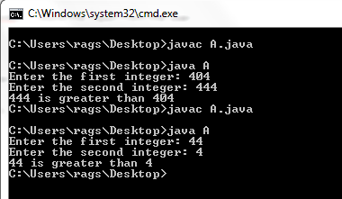

2.Find Minimum of 2 nos. using conditional operator

CODE

import java.util.Scanner; //import the framework

class A{

public static void main(String args[]){

Scanner input = new Scanner(System.in); //opens a scanner, keyboard

System.out.print("Enter the first integer: "); //prompt the user

int myInt = input.nextInt(); //store the input from the user

int i=myInt;

System.out.print("Enter the second integer: "); //prompt the user

myInt = input.nextInt(); //store the input from the user

int j=myInt;

System.out.println("i value is"+i);

System.out.println("j value is"+j);

int min = (i < j) ? i : j;

System.out.println("minimum of two numbers is"+ " "+min );

}

}

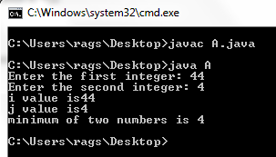

3. Write a program that will read a float type value from the keyboard and print the following output.

->Small Integer not less than the number.

->Given Number.

->Largest Integer not greater than the number.

CODE

import java.util.Scanner; //import the framework

class A{

public static void main(String args[]){

Scanner input = new Scanner(System.in); //opens a scanner, keyboard

System.out.print("Enter the floating point number: "); //prompt the user

float myInt = input.nextFloat(); //store the input from the user

int i = (int)myInt;//typecasting

System.out.println("Small Integer not less than number is"+" "+i);

System.out.println("Given floating point number"+" "+myInt);

System.out.println("Largest Integer not greater than number is"+" "+i);

}

}

OUTPUT

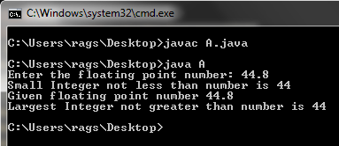

4. Write a program to generate 5 Random nos. between 1 to 100, and it should not follow with decimal point.

5. Write a program to display a greet message according to Marks obtained by student.

import java.util.Scanner; //import the framework

class A{

public static void main(String args[]){

Scanner input = new Scanner(System.in); //opens a scanner, keyboard

System.out.print("Enter the marks obtained by the student: "); //prompt the user

int marks = input.nextInt(); //store the input from the user

if(marks>=80)

System.out.println("Congrats you got Grade A" );

else if (marks>=70 && marks <80)

System.out.println("You got Grade B" );

else if (marks>=60 && marks <70)

System.out.println("You got Grade C" );

else

System.out.println("Need to do the course again" );

}

}

OUTPUT

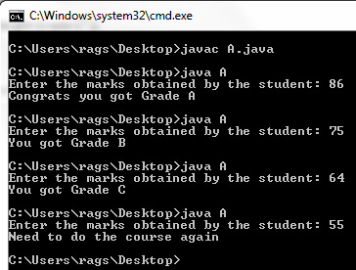

## 6. java program to find sum and product of all digits of a number using

In this program we will read a positive integer number and then calculate product of all digits using a class. For example, if input number is **12345** - sum of all digits, product of all digits will be **15**, **120**..

//Java program to find sum and product of all digits using class.

CODE

import java.util.Scanner; //import the framework

public class A{

int funSum(int digit)

{

int rem=0;

int sum=0;

while(digit!=0)

{

rem=digit%10;

digit=digit/10;

sum=sum+rem;

}

return sum;

}

int funProduct(int digit)

{

int rem=0;

int product=1;

while(digit!=0)

{

rem=digit%10;

digit=digit/10;

product=product*rem;

}

return product;

}

public static void main(String args[]){

Scanner input = new Scanner(System.in); //opens a scanner, keyboard

System.out.print("Enter the number: "); //prompt the user

int number = input.nextInt(); //store the input from the user

A a= new A();

int sum=a.funSum(number);

System.out.println("Sum of "+number+" is " +sum);

int product=a.funProduct(number);

System.out.println("Product of "+number+" is " +product);

}

}

OUTPUT

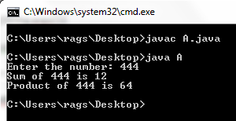

Without functions

import java.util.Scanner; //import the framework

class A{

public static void main(String args[]){

Scanner input = new Scanner(System.in); //opens a scanner, keyboard

System.out.print("Enter the number: "); //prompt the user

int number = input.nextInt(); //store the input from the user

int digit=number;

int rem=0,sum=0,product=1;

while(digit!=0)

{

rem=digit%10;

digit=digit/10;

sum=sum+rem;

product=product*rem;

}

System.out.println("Sum of "+number+" is " +sum);

System.out.println("Product of "+number+" is " +product);

}

}

OUTPUT

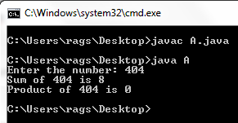

7. A program to find Factorial of Given no.

import java.util.Scanner; //import the framework

class A{

public static void main(String args[]){

Scanner input = new Scanner(System.in); //opens a scanner, keyboard

System.out.print("Enter the number: "); //prompt the user

int number = input.nextInt(); //store the input from the user

int digit=number;

int rem=0,sum=0,product=1;

for(int i=1;i<=digit;i++)

{

product *=i;

}

System.out.println("Factorial of given "+number+" is " +product);

}

}

OUTPUT

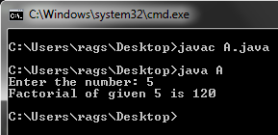

8. A program to reverse a given no.

import java.util.Scanner; //import the framework

class A{

public static void main(String args[]){

Scanner input = new Scanner(System.in); //opens a scanner, keyboard

System.out.print("Enter the number: "); //prompt the user

int number = input.nextInt(); //store the input from the user

int digit=number;

int rem=0,sum=0,result=0;

while (digit!=0)

{

rem = digit % 10;

digit = digit / 10;

result = result * 10 + rem;

}

System.out.println("Reverse of given "+number+" is " +result);

}

}

OUTPUT

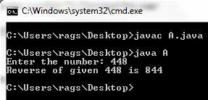

9. Write a program to find Fibonacci series of a given no.

//Write a program to find Fibonacci series of a given no.

import java.util.Scanner; //import the framework

class A{

public static void main(String args[]){

Scanner input = new Scanner(System.in); //opens a scanner, keyboard

System.out.print("Enter the number: "); //prompt the user

int number = input.nextInt(); //store the input from the user

int digit=number;

int a=0,b=1,sum=0;

if (digit==0)

System.out.println("0");

else if(digit==1)

System.out.println("0 1");

else

{

System.out.print("0 1 ");

for (int i=2;i<=digit;i++)

{

sum=a+b;

System.out.print(sum+" ");

a=b;

b=sum;

}

}//else

}

}

OUTPUT

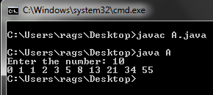

10. Write a program to find sum of all integers greater than 100 and less than 200 that are divisible by 7

import java.util.Scanner; //import the framework

class A{

public static void main(String args[]){

int sum=0;

for (int i=100;i<=200;i++)

{

if ((i % 7)==0)

sum=sum+i;

}

System.out.print("The sum of no's divisible by 7 b/w 100 and 200 is "+sum);

}

}

OUTPUT

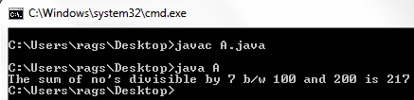

11.Write a program to Concatenate string using for Loop

Example: Input - 5 Output - 1 2 3 4 5

12. Program to Display Multiplication Table

CODE

import java.util.Scanner; //import the framework

class A{

public static void main(String args[]){

Scanner input = new Scanner(System.in); //opens a scanner, keyboard

System.out.print("Enter the number: "); //prompt the user

int number = input.nextInt(); //store the input from the user

int sum=0,rslt=0;

System.out.println("Table for number: "+number);

for (int i=1;i<=10;i++)

{

rslt=number*i;

System.out.println(number+" * "+i+" = " +rslt);

}//for loop

}

}

OUTPUT

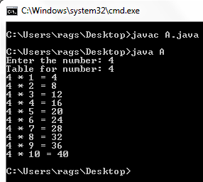

13. Write a program to Swap the values

CODE

//10.Write a program to find sum of all integers greater than 100 and less than 200 that are divisible by 7

import java.util.Scanner; //import the framework

class A{

public static void main(String args[]){

Scanner input = new Scanner(System.in); //opens a scanner, keyboard

System.out.print("Enter the first number: "); //prompt the user

int a = input.nextInt(); //store the input from the user

System.out.print("Enter the second number: "); //prompt the user

int b = input.nextInt(); //store the input from the user

System.out.println("The numbers before swapping are a= "+a+" and b= "+b); //prompt the user

a=a+b;

b=a-b;

a=a-b;

System.out.println("The numbers after swapping are a= "+a+" and b= "+b);

}

}

OUTPUT

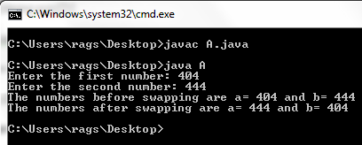

14. Write a program to convert given no. of days into months and days.

CODE

//10.Write a program to find sum of all integers greater than 100 and less than 200 that are divisible by 7

import java.util.Scanner; //import the framework

class A{

public static void main(String args[]){

Scanner input = new Scanner(System.in); //opens a scanner, keyboard

System.out.print("Enter the number of days: "); //prompt the user

int days = input.nextInt(); //store the input from the user

if (days<30)

System.out.println(days+" days ");

else

{

int months=days/30;

int rem=days%30;

System.out.println(months+" months and "+rem+" days");

}

}

}

OUTPUT

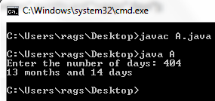

15. Write a program to generate a Triangle.

CODE

//10.Write a program to find sum of all integers greater than 100 and less than 200 that are divisible by 7

import java.util.Scanner; //import the framework

class A{

public static void main(String args[]){

Scanner input = new Scanner(System.in); //opens a scanner, keyboard

System.out.print("Enter the number of rows you like to print as a triangle: "); //prompt the user

int no= input.nextInt(); //store the input from the user

for (int i=1;i<=no;i++)

{

for (int j=1;j<=i;j++)

{

System.out.print(i+" ");

}//inner for loop

System.out.println(" ");

}//outer for loop

}

}

OUTPUT

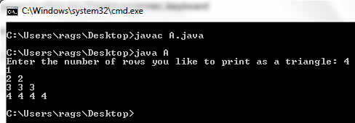

16. Write a program to Display Invert Triangle.

CODE

//10.Write a program to find sum of all integers greater than 100 and less than 200 that are divisible by 7

import java.util.Scanner; //import the framework

class A{

public static void main(String args[]){

Scanner input = new Scanner(System.in); //opens a scanner, keyboard

System.out.print("Enter the number of rows you like to print as an inverse triangle: "); //prompt the user

int no= input.nextInt(); //store the input from the user

for (int i=no;i>=1;i--)

{

for (int j=1;j<=i;j++)

{

System.out.print(i+" ");

}//inner for loop

System.out.println(" ");

}//outer for loop

}

}

OUTPUT

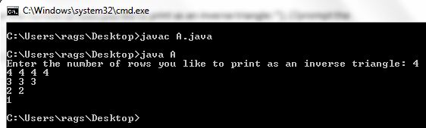

17. Write a program to find whether given no. is Armstrong or not.

import java.util.Scanner; //import the framework

class A{

public static void main(String args[]){

Scanner input = new Scanner(System.in); //opens a scanner, keyboard

System.out.print("Enter the number you want to check: "); //prompt the user

int no= input.nextInt(); //store the input from the user

int dig=no;

int sum=0,rem=0;

while( dig!= 0 )

{

rem = dig%10;

sum = sum + rem*rem*rem;

dig = dig/10;

}

if ( no== sum )

System.out.println("Entered number is an armstrong number.");

else

System.out.println("Entered number is not an armstrong number.");

}

}

OUTPUT

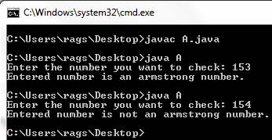

18. Write a program to Find whether number is Prime or Not.

import java.util.Scanner; //import the framework

class A{

public static void main(String args[]){

Scanner input = new Scanner(System.in); //opens a scanner, keyboard

System.out.print("Enter the number you want to check: "); //prompt the user

int no= input.nextInt(); //store the input from the user

int count=0;

if(no<=1)

System.out.println(" The number is not a prime number");

else

{

for(int i=2; i<=no/2; i++)

{

if(no % i == 0)

count++;

}

if (count<2)

System.out.println(" The number is a prime number");

else

System.out.println(" The number is not a prime number");

}

}

}

OUTPUT

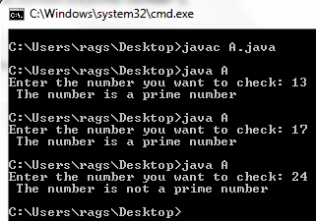

19. Write a program to find whether no is palindrome or not.

CODE

import java.util.Scanner; //import the framework

class A{

public static void main(String args[]){

Scanner input = new Scanner(System.in); //opens a scanner, keyboard

System.out.print("Enter the number you want to check: "); //prompt the user

int num= input.nextInt(); //store the input from the user

int temp=num;

int r=0,sum=0;

while(num!=0){

r=num%10;

num=num/10;

sum=sum*10+r;

}

if(sum==temp)

System.out.print("The number is a palindrome: ");

else

System.out.print("The number is not a palindrome: ");

}

}

OUTPUT

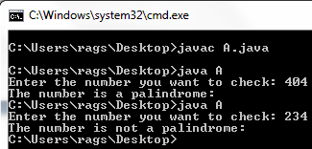

20.switch case demo

Example : Input - 124 Output - One Two Four

CODE

import java.util.Scanner; //import the framework

class A{

public static void main(String args[]){

Scanner input = new Scanner(System.in); //opens a scanner, keyboard

System.out.print("Enter the number: "); //prompt the user

int num= input.nextInt(); //store the input from the user

int temp=num;

int rem=0,result=0;

while(num!=0)

{

rem = num % 10;

num=num/10;

result = result * 10 + rem;

}

while(result!=0)

{

rem=result%10;

result=result/10;

switch(rem)

{

case 0:

System.out.print(" zero");

break;

case 1:

System.out.print(" one");

break;

case 2:

System.out.print(" two");

break;

case 3:

System.out.print(" three");

break;

case 4:

System.out.print(" four");

break;

case 5:

System.out.print(" five");

break;

case 6:

System.out.print(" six");

break;

case 7:

System.out.print(" seven");

break;

case 8:

System.out.print(" eight");

break;

case 9:

System.out.print(" nine");

break;

default:

System.out.println("not a valid number");

}//switch

}//while

}

}

OUTPUT

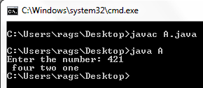

21. Write a program to generate Harmonic Series.

Example: Input - 5 Output - 1 + 1/2 + 1/3 + 1/4 + 1/5 = 2.28 (Approximately)

CODE

import java.util.Scanner; //import the framework

class A{

public static void main(String args[]){

Scanner input = new Scanner(System.in); //opens a scanner, keyboard

System.out.print("Enter the series length: "); //prompt the user

int num= input.nextInt(); //store the input from the user

double rst=0.0;

for(int i=1;i<=num;i++)

{

System.out.print("1/"+i+" +");

rst = rst + (double) 1 / i;

}

System.out.println("Sum of Harmonic Series is "+rst);

}

}

OUTPUT

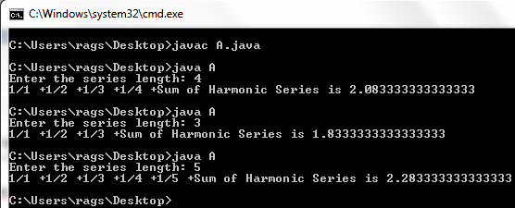

22. A program to find average of consecutive N Odd no. and even no.

CODE

import java.util.Scanner; //import the framework

class A{

public static void main(String args[]){

Scanner input = new Scanner(System.in); //opens a scanner, keyboard

System.out.print("Enter the number till which you like to find the sum: "); //prompt the user

int num= input.nextInt(); //store the input from the user

int sum1=0,sum2=0;

for(int i=1;i<=num;i++)

{

if (i%2==0)

{

sum1=sum1+i;

}

else

{

sum2=sum2+i;

}}

System.out.println("Sum of even consecutive numbers till "+num+" is "+sum1);

System.out.println("Sum of odd consecutive numbers till "+num+" is "+sum2);

}}

OUTPUT

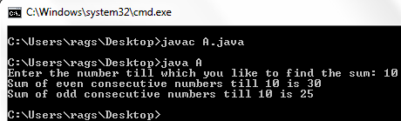

23. Display Triangle as follow: BREAK DEMO.

1

2 3

4 5 6

7 8 9 10 ... N

CODE

import java.util.Scanner; //import the framework

class A{

public static void main(String args[]){

Scanner input = new Scanner(System.in); //opens a scanner, keyboard

System.out.print("Enter the number of rows you like to print as a triangle: "); //prompt the user

int no= input.nextInt(); //store the input from the user

int k=1;

for (int i=1;i<=no;i++)

{

for (int j=1;j<=i;j++)

{

System.out.print(k+" ");

k++;

}//inner for loop

System.out.println(" ");

}//outer for loop

}

}

OUTPUT

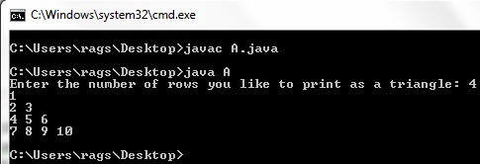

24.Display Triangle as follow

0

1 0

1 0 1

0 1 0 1

CODE

import java.util.Scanner; //import the framework

class A{

public static void main(String args[]){

Scanner input = new Scanner(System.in); //opens a scanner, keyboard

System.out.print("Enter the number of rows you like to print as a triangle: "); //prompt the user

int no= input.nextInt(); //store the input from the user

int k=1;

for (int i=1;i<=no;i++)

{

for (int j=1;j<=i;j++)

{

if (k%2==0)

System.out.print(1+" ");

else

System.out.print(0+" ");

k++;

}//inner for loop

System.out.println(" ");

}//outer for loop

}

}

OUTPUT

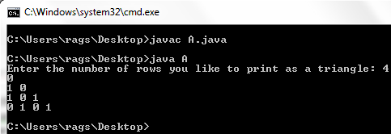

25. Display Triangle as follow

1

2 4

3 6 9

4 8 12 16 ... N (indicates no. of Rows)

CODE

import java.util.Scanner; //import the framework

class A{

public static void main(String args[]){

Scanner input = new Scanner(System.in); //opens a scanner, keyboard

System.out.print("Enter the number of rows you like to print as a triangle: "); //prompt the user

int no= input.nextInt(); //store the input from the user

int k=1;

for (int i=1;i<=no;i++)

{

for (int j=1;j<=i;j++)

{

System.out.print(i*j+" ");

}//inner for loop

System.out.println(" ");

}//outer for loop

}

}

OUTPUT

